Chapter1

**APPLICATION OF MACHINE LEARNING TECHNIQUES FOR TONGUE DIAGNOSIS IN AYURVEDA**

**N. Satish Kumara*, Harshvardhan Tiwarib, Balaji Sb, Prabhanjan Sc, Meenakshi Malhothrac, Pallavi C Va, Sumanth N Sa\***

**a*ISE Department, Jyothy Institute of technology, Bengaluru, India**

**bCIIRC, Jyothy Institute of Technology, Bengaluru, India**

**cCSE Department, Jyothy Institute of Technology, Bengaluru, India**

# INTRODUCTION

Tongue Diagnosis is one of the critical substances of "Four Diagnoses" in Ayurveda Medicine. The "Four Diagnoses" implies perception, tuning in, cross-examination and heartbeat taking. Conventional tongue analyzes rely upon perceptions of tongue highlights, for example, shading, shape, dampness, and surface by AYURVEDA specialists. The aftereffects of tongue analyze are affected by the experience of AYURVEDA specialists as well as by the encompassing conditions. Along these lines, these days numerous specialists utilize a computerized camera to take tongue photographs and use the Computer Vision (CV) to make quantitative checks and examinations of tongue images, that is, a generalization of tongue analysis. To check and dissect tongue images quantitatively, we initially need to fragment tongue body area out of the face image which is purported to be tongue image extraction. As of late, different sorts of image division techniques have been connected to the use of tongue image extraction. Among these strategies, the delegate ones are active contour; level sets technique, region growing, random walk technique, and many more. Dynamic shape technique which was supposed to be Snakes algorithm was generally

utilized for extracting tongue region for diagnosis applications. The next section summarizes the related research work in tongue diagnosis.

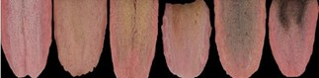

Fig. 1 Tongue coating color sample

# RELATED WORK

Shi et al. [1] used geodesic dynamic shape model to influence tongue image division. The proposed approach could improve the precision and practicability clearly, contrasted and other work. At the point when the surface of the tongue was not general, this may prompt an inability to remove tongue body area out of the surface effectively. Shi et al. [2] introduced a completely automated active contour technique that used previous information of the tongue shape and its area in tongue images. This strategy expanded the curve velocity however decreasing the complexness. The main drawback of this technique is that four points were required to specify by the user to indicate the initial contour of the tongue body. Liang and Shi [3] proposed another tongue segmentation approach in light of the mix of the element of tongue shape and the Snakes correction model. In this strategy, a harsh tongue shape was not utilizing the highlights of tongue image in HSI color model. The experiments shows that this technique was effective on however, the quantity of the trial tests was very constrained. Zhai et al. [4] converted tongue image from RGB to HSI color model and double Snake calculation was utilized to get the exact form of the tongue body. Through testing, this strategy had ended up being palatable for the particular tongue image extraction. Be that as it may, the underlying inside shape and initial outside form while executing the double Snake calculation were hard to acquire, so this strategy is very hypothetical from a specific perspective. Ning et al. [5] exhibited a programmed tongue segmentation strategy which utilized a region merging technique to make segmentation and used Snakes calculation to refine the segmentation result. The proposed technique incredibly upgraded the segmentation results; however, the precision of this strategy was not high when preparing some tongue image tests given by the author. Li [6] recommended a sort of tongue image extraction technique utilizing enhanced Snake. Through the base figuring of Snake, evaluated shape line was additionally prepared which could enhance the precision of tongue image extraction, however, the proficiency of the proposed strategy isn't specified in the article. Wang et al. [7] proposed an enhanced tongue image extraction approach in light of Snakes model, in which the tongue image was portrayed in two other color spaces and a two-advance Snake model was utilized. The exactness and unwavering quality of this technique were enhanced; however the proficiency of this strategy may be very low because of preparing with high intricacy utilizing this strategy. Fu et al. [8] utilized radial edge identification to get the rough form of the tongue image, used combine color evacuate to remove the lip, and connected Snakes technique to get the correct shape of the tongue. The precision of this strategy was demonstrated in the test, yet the productivity of this technique was not specified in the article. This paper utilized RGB color space with edge information for initial segmentation of the tongue area and CIELAB color space for body and coating

segmentation of tongue. This segmentation is first and foremost step in tongue diagnosis in Ayurveda medicine. Due to the constant term, gradient-based active contour models evolve the contour towards just one manner, every within or outside. Therefore, a primary contour should be placed.

## PROPOSED METHOD

The complete workflow of the proposed method of tongue body and coating segmentation is given in fig. 1 which includes initial tongue region segmentation using semi automated approach using RGB along with edge information; tongue body and coating segmentation using k-means clustering algorithm on CIELAB color space.

## INITIAL TONGUE REGION SEGMENTATION USING ACTIVE CONTOUR ALGORITHM

In this proposed method of tongue body and coating segmentation we use semi-automated initial tongue region segmentation using Active contour segmentation algorithm based on the edge information. This section summarizes the active contour segmentation model based on edge information.

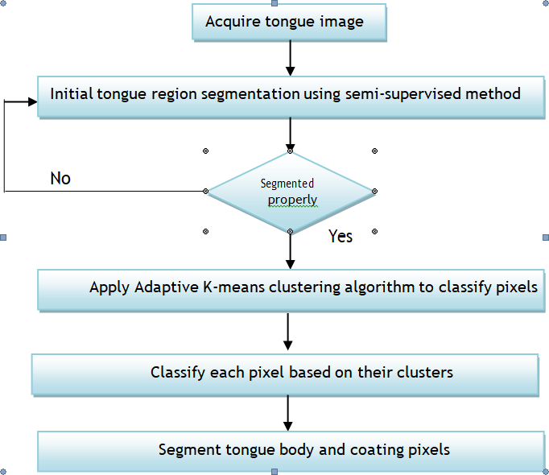

Fig. 2 Proposed Tongue Body and Coating separation using Clustering approach

* 1. ***ACTIVE CONTOURS BASED ON EDGE***

Active contours using gradient information is categorized as edge-based segmentation. Due to the constant term, gradient-based active contour models evolve the contour towards just one manner, every within or outside. Therefore, a primary contour should be placed. Fully within or outside of region of interest, and still few previous information is necessary. Also, active contours have a few disadvantages which are inherited from edge- based segmentation. Since each edge-based segmentation and edge based active contour accept the image gradient method, edge-based active contours might omit the foggy boundaries, and that they square measure sensitive to native minima or noise as edge-based segmentation will. Gradient vector flow fast geodesic dynamic contours [21-22] proposed by author replaced the border detection (boundary attraction) word with gradient vector field [23-27], that refers to a spatial diffusion of the boundary data and guides the propagation to the object boundaries from equal sides, to offer additional freedom from the restriction of initial contour position. The performance of the active contour segmentation algorithm using edge information is very good and the same is reported in this paper.

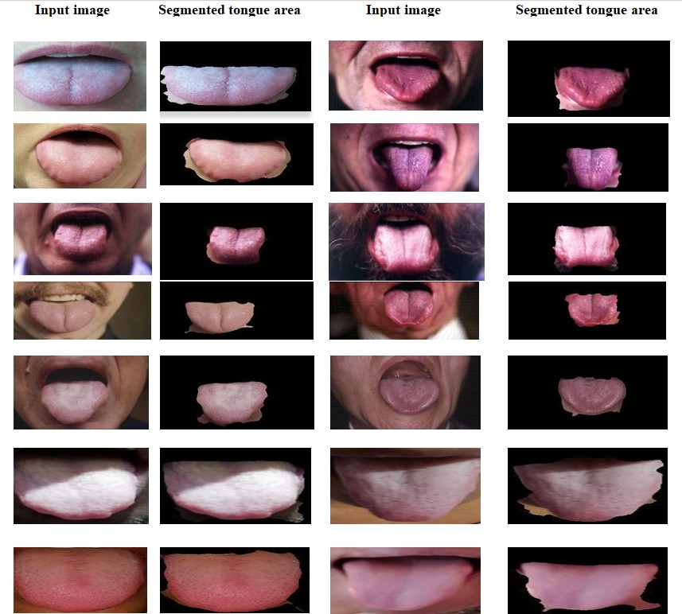

Fig. 3 Initial tongue area segmentation results with active contour segmentation algorithm

Lab is the CIELAB color value for each pixel of the given tongue image. K-means clustering approach of Machine learning is used segmentation of ROI with respect to image processing. The K-means method is a vector quantization method that assumes each pixel of an image as having a location in space. The chrominance values a*, b* and luminance L* are important features applied for tongue body and coating separation. By labeling each cluster according to its Euclidean distance metric and color, the average tongue body and coating color in the cluster can be determined and analyzed. A flowchart of the K-means clustering algorithm is shown in Fig. 2.

K.-means clustering algorithm with value k = 3 on CIELAB color space to segment tongue body and coating using MATLAB. The tongue surface typically comprises a coating area, a body area (non-coating rim area). Thus, we considered three clusters reasonable for distinguishing these areas and the background. Clustering results with 1) background (black), 2) tongue coating, 3) tongue body areas are shown in Fig. 2, 3, and 4 for k=3, k=4 and k=5 respectively. For k=4 over segmented regions are resulted, for k=5 the results still be over segmented, thus for k=3 is the correct number of clusters for the case of tongue body and coating segmentation.

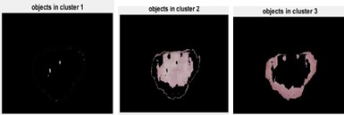

Fig. 4 clustering results (k=3)

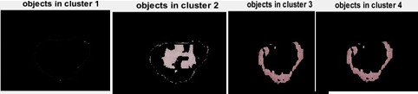

Fig. 5 clustering results (k=4)

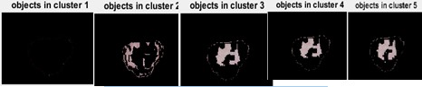

Fig. 6 clustering results (k=5)

## ANALYSIS OF PROCESSED IMAGES:

Images for experimentation purpose have been captured from high quality camera with sufficient lighting condition. The accuracy of our planned segmentation with ineffective options removal was verified victimization the labeled knowledge confirmed by ayurveda practitioner. The initial segmentation of tongue area is about 90% accurate, and tongue body and coating segmentation on LAB color space is about 90% accurate.

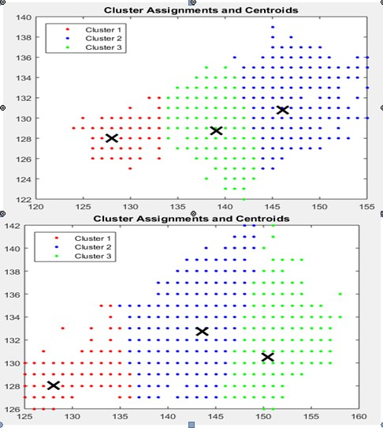

Fig. 7 Distribution of tongue body and coating pixels in CIE lab color space of a* and b* (x) indicates the centroid of each cluster.

## CONCLUSION:

Several previous methods of analysis in computerized tongue diagnostic system, however, the segmentation of tongue attain higher solutions; still there is need of good segmentation algorithms for initial tongue area separation, tongue body and coating segmentation for ayurveda medicine. The tongue body and coating separation is very important preliminary step for automated tongue diagnosis in ayurveda medicine.

In this paper we implemented active contour segmentation algorithm using edge information for initial segmentation of tongue area from the input image. The developed segmentation algorithm’s performance is very good and achieved about 90% accuracy and same is reported.

After initial tongue area segmentation very important step is separation of tongue body and coating for accurate tongue diagnosis in ayurveda medicine. For separation this research work implemented clustering algorithm using k- means clustering with (k=3) based on CIELAB color space. It is found that separation results of tongue body and coating is very good.

# REFERENCES:

[1](M. J. Shi, G. Z. Li, F. F. Li, and C. Xu, July 2012) “A novel tongue segmentation approach utilizing double geodesic flow,” in Proceedings of the 7th International Conference on Computer Science and Education (ICCSE ’12), pp. 21–25, Melbourne, Australia<<a>>.

[2](M. J. Shi, G. Z. Li, and F. F. Li, 2013) “C2 G2. FSnake: automatic tongue image segmentation utilizing prior knowledge,” Science China Information Sciences, vol. 56, no. 9, pp. 1–14<<b>>.

[3](C. Liang and D. C. Shi, March 2012) “A prior knowledge-based algorithm for tongue body segmentation,” in Proceedings of the International Conference on Computer Science and Electronics Engineering (ICCSEE ’12), pp. 646–649, Hangzhou, China.

[4](X. M. Zhai, H. D. Lu, and L. Z. Zhang, May 2009) “Application of image segmentation technique in tongue diagnosis,” in Proceedings of the International Forum on Information Technology and Applications (IFITA ’09), pp. 768–771, Chengdu, China.

[5](J. F. Ning, D. Zhang, C. K. Wu, and F. Yue, 2012) “Automatic tongue image segmentation based on gradient vector flow and region merging,” Neural Computing and Applications, vol. 21, no. 8, pp. 1819–1826.

[6](S. X. Li, 2009) “Automatic segmentation of tongue image based on histogram threshold and snakes model,” Journal of University of Science and Technology Liaoning, vol. 32, no. 6, pp. 585–590.

[7](M. Y. Wang, X. F. Zhang, and Z. Li, 2011) “An improved snakes model for tongue image segmentation,” Measurement and Control Technology, vol. 30, no. 5, pp. 32–35.

[8](Z. C. Fu, X. Q. Li, and F. F. Li, 2009) “Tongue image segmentation based on snake model and radial edge detection,” Journal of Image and Graphics, vol. 14, no. 4, pp. 688–693.

[9]( N. Paragios, O. Mellina-Gottardo, and V. Ramesh, 2004) “Gradient vector flow fast geometric active contours,” IEEE Transactions on Pattern Analysis and Machine Intelligence, no. 3, pp. 402–407<<a>>.

[10]( N. Paragios, O. Mellina-Gottardo, and V. Ramesh, 2001) “Gradient vector flow fast geodesic active contours,” in Proc. of IEEE International Conference on Computer Vision<<b>>.

[11](C. Xu and J. Prince, 2000) Handbook of Medical Imaging: Processing and Analysis Management, ch. Gradient Vector Flow Deformable Models. Academic Press<<a>>.

[12](C. Xu, D. Pham, and J. Prince, 2000) Handbook of Medical Imaging: Processing and Analysis Management, ch. Image Segmentation Using Deformable Models, pp. 129–174.

Academic Press.

[13](C. Xu and J. Prince, 1998) “Generalized gradient vector flow external forces for active contours,” Signal Processing, no. 3, pp. 131–139<<b>>.

[14](C. Xu and J. Prince, 1998) “Snakes, shapes, and gradient vector flow,” IEEE Transactions on Image Processing, no. 3, pp. 359–369<<c>>.

[15](C. Xu and J. Prince,1997) “Gradient vector flow: a new external force for snakes,” in Proc. of IEEE Conference on Computer Vision and Pattern Recognition, pp. 66–71<<d>>.